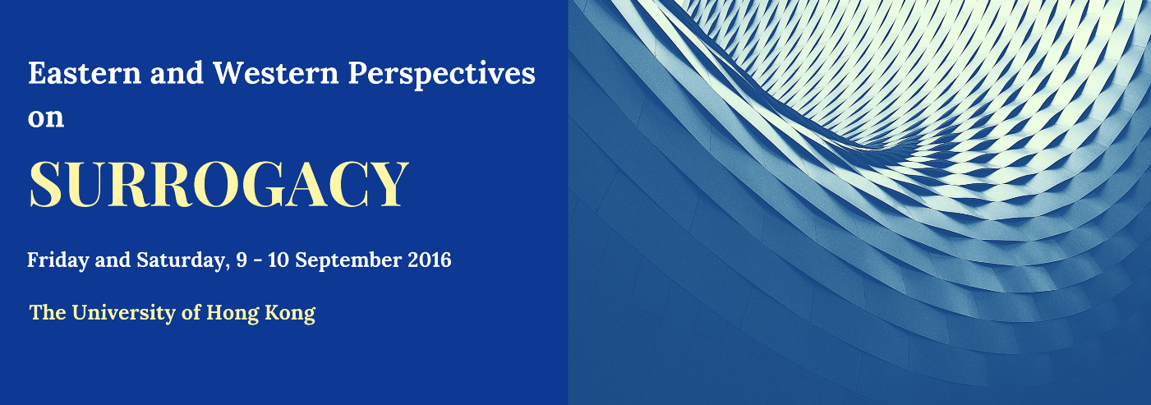
With the advances in artificial reproductive techniques, and an increasingly globalised world, surrogacy has gone from a niche practice to a global market, raising questions of parenthood, conflict of laws, and the commercialisation of the birth process. While there have been comparative studies undertaken concerning approaches to surrogacy from Europe and "Western" jurisdictions, there is gap in the literature with regard to the approach international surrogacy in Asia (and indeed Africa). As such, this conference will bring together academics from both Eastern and Western jurisdictions in order to provide a more comprehensive understanding of the confluences and tensions between the way in which surrogacy is approached in these two regions.

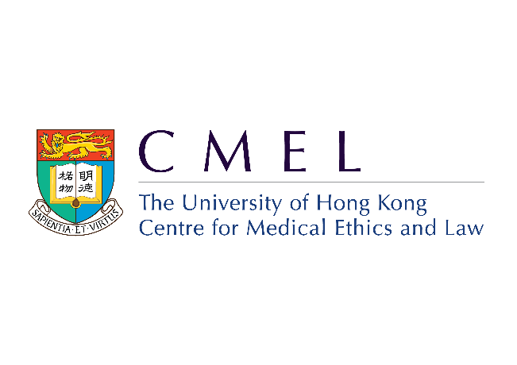
Project Leaders : Jens M. Scherpe, Claire Fenton-Glynn and Terry Kaan

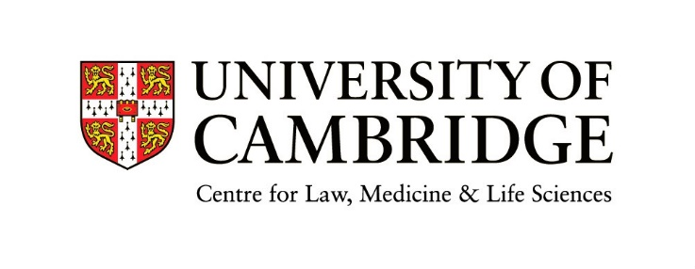

GENERAL INFORMATION

Conference Venues
The Conference will be held in the Wang Gungwu Lecture Theatre, Level P4, Graduate House, The University of Hong Kong.

WiFi
FREE WiFi service is provided in the conference venue. Connection to Wi-Fi.HK via HKU is easy and no registration is required. Only 3 steps to connect:
1. Ensure that WiFi is turned ON
2. Find the access point “Wi-Fi.HK via HKU”
3. Open a browser and accept the Terms and Conditions
For delegates and participants with an account from an academic institution, access via the eduroam service is also available. Please log onto the eduroam access point, entering your full email address (e.g. onetwothree@abc.edu) and your email password for that account.
Detailed connection procedures for different operating systems can be found at:
http://www.its.hku.hk/documentation/guide/network/wifi/wifihk

Badges
For security reasons and catering purposes, please wear your name badge during the conference. Re-placement for lost badges are available from the registration desk.

Lunch
There are a number of places on campus where you can obtain a variety of refreshments at your own cost:
1. Rome Café, Level P3, Graduate House
2. Subway, Run Run Shaw Podium
3. Starbuck’s Coffee, G/F, Old Wing of the Library Building
4. BIJAS Vegetarian (一念素食), G/F, Run Run Shaw Tower, Central Podium, Centennial Campus

PROGRAMME:

Eastern and Western Perspectives on Surrogacy

9 and 10 September 2016

DAY ONE (9 September 2016)
9:00-9.30am: Registration and Morning Coffee

9:30-9:45am: Welcome address (Prof Michael Hor, Dean of the Faculty of Law)

9:45-11:00am: The prohibitive approach: France, Germany; View from the bench (Germany)
Chair: Prof Esther Farnós Amorós (Universitat Pompeu Fabra, Barcelona)
Speakers: Prof Walter Pintens (Catholic University of Leuven)
Prof Anatol Dutta (University of Regensburg)
Dr Frank Klinkhammer (Judge, German Federal Court of Justice)

11:00-11:30am: Coffee

11:30-1:00pm: The tolerant approach: England, Australia, New Zealand
Chair: Marcus Dearle (Berwin Leighton Paisner (HK))
Speakers: Dr Claire Fenton-Glynn (University of Cambridge)
Prof Mary Keyes (Griffith University)
Dr Debra Wilson (University of Canterbury)
1:00-1.30pm Key Note Address: Sir Mark Hedley (retired High Court Judge, England and Wales)

1:30-2:15pm: Lunch

2:15-3:15pm: The regulatory approach: South Africa, Israel
Chair: Matthew Jolley (Law Commission, England & Wales)
Speakers: Dr Debbie Horsten (Stellenbosch University)
Prof Rhona Schuz (Sha'arei Mishpat Academic Center)

3:15-3:45pm: Coffee

3:45-5:15pm: The free market approach: Russia, USA, India
Chair: Prof Johannes Chan SC (Hon) (University of Hong Kong)
Speakers: Prof Olga Khazova (Institute of State & Law, Russian Academy of Sciences)
Prof June Carbone (University of Minnesota)
Dr Prahba Kotiswaran (King’s College London)

Evening: Conference Dinner

DAY TWO (10 September 2016)

8:30-9:00am: Registration and Morning Coffee

9:00-9:30: Key Note Address: Chief Justice John Pascoe (Federal Court of Australia)

9:30-11:00am: The East Asian approach I: Hong Kong SAR, Singapore, Taiwan
Chair: Azan Marwah (Gilt Chambers, Hong Kong)
Speakers: Prof Daisy Cheung (University of Hong Kong)
Prof Terry Kaan (University of Hong Kong)
Dr Chi-Hsing Ho (Academia Sinica)

11:00-11:30am: Coffee

11:30-1:00pm: The East Asian approach II: Japan, South Korea, Thailand
Chair: Spencer Clarke (Law Commission, England and Wales)
Speakers: Prof Soraj Hongladarom (Chulalongkorn University)
Prof Shinichiro Hayakawa (University of Tokyo)

1:00-1:30pm: Lunch

1:30-1:50pm: The Process of Law Reform: Prof Nick Hopkins (Law Commissioner, England and Wales)

1:50-3:00pm: General Discussion and Concluding Remarks
Chair: Prof Jens M. Scherpe (University of Cambridge / University of Hong Kong)
List of Speakers and Contributors (by alphabetical order)

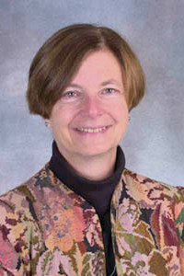
Professor June CARBONE is the Robina Chair of Law, Science and Technology and Associate Dean for Research and Planning at the University of Minnesota. Previously she has served as the Edward A. Smith/Missouri Chair of Law, the Constitution and Society at the University of Missouri at Kansas City, and Associate Dean for Professional Development and Presidential Professor of Ethics and the Common Good at Santa Clara University School of Law. She received her J.D. from the Yale Law School, and her A.B. from the Woodrow Wilson School of Public and International Affairs at Princeton University. She teaches Property, Family Law, and Assisted Reproduction and the Family. She has written From Partners to Parents: The Second Revolution in Family Law (Columbia University Press, 2000), the third, fourth and fifth editions of Family Law with Leslie Harris and the late Lee Teitelbaum (Aspen, 2005, 2009, 2014), Red Families v. Blue Families (Oxford University Press, 2010); Marriage Markets: How Inequality is Remaking the American Family (Oxford University Press, 2014), both with Naomi Cahn. She is a member of the Yale Cultural Cognition Project.

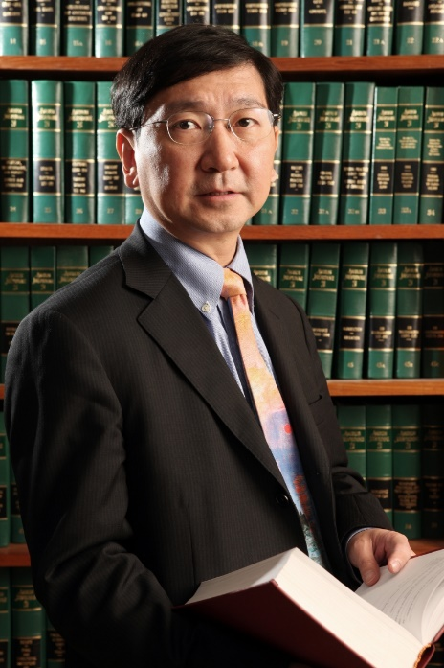
Professor Johannes M M Chan is Professor of Law and former Dean of the Faculty of Law (2002-2014), being the longest serving Dean of the Faculty. He was also a visiting professor to a number of universities in Europe and Asia, including being the BOK Visiting International Professor of Penn Law School, University of Pennsylvania (2014), Herbert Smith Freehills Visiting Professor of Cambridge University (2015), and a visiting fellow of Gonville and Caius College, Cambridge University. In recognition of his distinguished contribution to legal development through both advocacy in courts and legal research and publications, he was honoured by the Chief Justice in 2003 by his appointment as the first (and so far the only) Honorary Senior Counsel in Hong Kong.
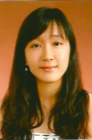
Ms Daisy CHEUNG is Assistant Professor, Faculty of Law, The University of Hong Kong; Board member, Centre for Medical Ethics and Law
Daisy’s research interests are primarily in the field of mental health law and ethics. Her interests also cover issues in assisted reproduction and developments in precision medicine.

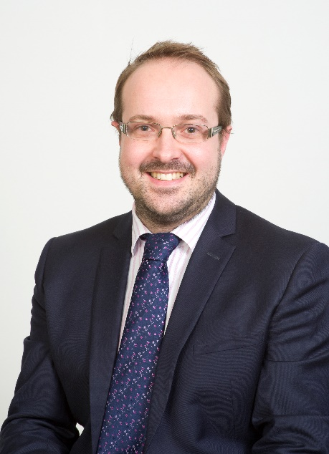
Mr Spencer CLARKE is a lawyer in the Property, Family and Trust Law team at the Law Commission for England and Wales. Spencer studied at the University of Nottingham; Goldsmiths, University of London; and what is now the University of Law before training as a solicitor at Withers LLP, qualifying in 2005. He practised as a family lawyer in London for 8 years, at Forsters LLP, specialising in high net worth financial settlements and private law children work, and trained as both a mediator and a collaborative lawyer. Spencer joined the Law Commission in 2013, focusing on family law and related areas; he has worked on reform projects on matrimonial property, needs and agreements; the enforcement of family financial orders; weddings; and wills.

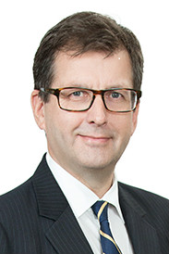
Mr Marcus DEARLE is a partner of Haley Tam & Co in association with Berwin Leighton Paisner, Hong Kong. He is a solicitor qualified in England & Wales, Hong Kong and the BVI. He was previously a partner of Withers, working for 19 years in its London office, before moving to Asia in 2009 to spearhead the formation of a family department in Hong Kong. He is listed as a leading individual in Chambers Asia Pacific and in 2015 was ranked as one of the "Top 10" family lawyers in Hong Kong by Spears Magazine, Asia.
He specialises in complex family law cases with an international element and has expertise in surrogacy law both in England and Hong Kong. He was one of the first to call for international surrogacy regulation back in 2001: he acted in the leading international surrogacy case of W and B v H (Child Abduction: Surrogacy) (No 1) [2002] 1 FLR 1008 and W v H (Child Abduction: Surrogacy) (No 2) [2002] 2 FLR 252 which went to the Court of Appeal in London.
He is a Fellow of the international Academy of Family Lawyers (IAFL) – and is a member of IAFL’s Assisted Reproduction Technology (ART) Committee. He is an officer of the Family Law Committee of the International Bar Association, IBA. He has regularly lectured on surrogacy law and has published articles including in the UK and Hong Kong national press: see article in UK Family Law Journal (FLJ) November 2001: “Avoiding the Pitfalls”.
In May 2015 he spoke at the IAFL Surrogacy Symposium in London. In October 2015, he chaired an IBA seminar in Vienna: "The Legal Pitfalls of International Surrogacy: the need for international regulation of surrogacy arrangements." In May 2016, he spoke on English and Hong Kong surrogacy law at the American Academy of assisted Reproduction Attorneys (AAARTA) annual conference in Denver, Colorado.

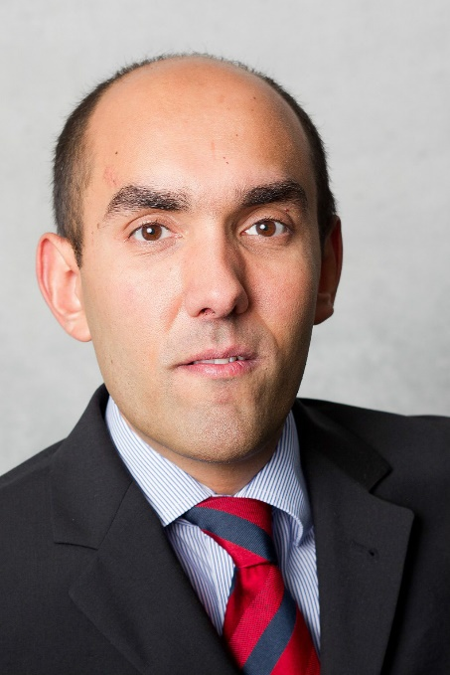
Professor Anatol DUTTA was born in 1976 in Munich. 1997-2002 Studies in law at the Ludwig Maximilians University of Munich. 2002 First State Examination. 2002-2003 Magister Juris (M. Jur.), University of Oxford. 2003-2006 Practical Legal Training (Referendariat), Hanseatic Court of Appeal, Hamburg. 2004 Summer course at the Hague Academy of International Law. 2006 Second State Examination.
2006 Doctor iuris (Dr. iur.), University of Hamburg; Otto Hahn Medal of the Max Planck Society for the Advancement of Science. December 2012 Habilitation at the University of Hamburg.
2003-2006 Research Associate, 2007-2014 Senior Research Fellow at the Max Planck Institute for Comparative and Private International Law. 2007-2013 Lecturer at the University of Hamburg
Lent term 2009 Visiting Fellow at the University of Cambridge. Guest lecturer at the Adam Mickiewicz University Poznań (since 2005), at Vienna University of Economics and Business (2007), at Kyushu University Fukuoka (2012), at the University of Auckland (EUCN Visiting Fellow 2013) and at Lomonosov Moscow State University (2015).

Since April 2014 full professor at the University of Regensburg
Member of the Academic Board of the Federal Association of German Civil Servants and of the German Council of Private International Law (Federal Ministry of Justice)
A recent list of publications can be obtained at www.uni-regensburg.de/law/civil-law/dutta/.

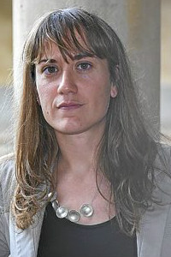
Professor Esther FARNÓS AMORÓS is a full time Lecturer in Civil Law at Pompeu Fabra University (Barcelona, Spain). She has been conducting research at the Oxford Centre for Family Law and Policy (Oxford University, 2005-2006), Cornell Law School (Cornell University, 2007-2008) and Autonomous University of Madrid (2013-2014), among other institutions.

Her main research interests lie in the fields of family law, bioethics and contracts. She holds a Ph.D. in Law from Pompeu Fabra University by a thesis on disputes over frozen embryos after divorce (IV Extraordinary Ph.D. in Law Prize, 2011) and is the author of a book on consent to ART (Consentimiento a la reproducción asistida. Crisis de pareja y disposición de embriones, Atelier, 2011), which was awarded the XIV Prize for Bioethical Research (Fundació Víctor Grífols i Lucas, 2012). She is the author of several book chapters and law review articles on topics such as family self-determination, parentage resulting from access to ART and the effectiveness of surrogacy agreements (“Surrogacy arrangements in a global world: the case of Spain”, International Family Law 1/2013, pp. 68-72). She is a member of the Harmonization Section of the Codification Committee of Catalonia, which is part of the Justice Department of the Catalan Government, and has been a member of the Bioethics Committee of Catalonia working group on the right to know one’s biological and genetic origins. Currently she is part of two research projects being carried out at Pompeu Fabra University and Autonomous University of Madrid, respectively, on reproductive freedom and building family relationships and the present and future of ART in twenty-first century family law in Spain and Latin America.

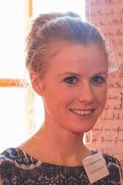
Dr Claire FENTON-GLYNN is a University Lecturer and Fellow in Law at Jesus College, University of Cambridge. She specialises in human rights and the protection of children, in particular focusing on issues such as intercountry adoption, international surrogacy, and cross-border child protection, as well as children's rights under the European Court of Human Rights. At the core of this research is the interaction between international and regional human rights instruments and domestic law, and the way in which these frameworks can be used to implement children’s rights. Her first book, "Children's Rights in Intercountry Adoption" was awarded the Inner Temple Book Prize for New Authors, as well as the University of Cambridge Faculty of Law's Yorke Prize. Claire is a member of the Centre for International Sustainable Development Law, and has worked as a consultant on issues concerning child protection, human rights, and rule of law with organisations such as the UN Office of the High Commissioner for Human Rights, the European Union, Save the Children and Avocats sans Frontières.

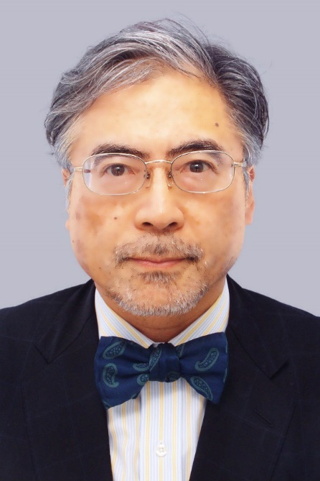
Professor Shinichiro HAYAKAWA is Professor of Law, University of Tokyo, Graduate School of Arts and Sciences, Department of Advanced Social and International Studies (Tokyo, Japan) Specialized in International Private Law, International Transaction Law, and Japanese Civil Law.

Graduated from Law Faculty of University of Tokyo. Worked as Research Associate in Law Faculty of University of Tokyo, Attorney at Law (Nagashima & Ohno in Tokyo), Associate Professor of Kansai University, Associate Professor of Nagoya University, and Professor of Tohoku University.
Served as Japanese delegate to the Hague Conference on Private International Law for the Project of Family Maintenance (2002-2007). Member of Legislative Council for Minister of Justice since 2013
Sir Mark HEDLEY was born in London in 1946 and is married with four children. After school, he read law at the University of Liverpool and was called to the Bar in 1969. He then served for a year as a volunteer teacher in the northern Sudan before returning to Liverpool to practice as a barrister, specialising in the law that most affected those at the bottom of the social pile but with an increasing emphasis on the law as it affects children.

Beginning his part-time judicial career in 1983, in 1992 he became a full-time Circuit Judge in Liverpool dealing with a wide range of cases but continuing the emphasis on cases affecting children. He was course director for family law at the Judicial Studies Board (now the Judicial College) from 1997 to 2002.

In 2002 he was appointed a High Court Judge in the Family Division (and in 2007 also in the Court of Protection) and was knighted. He also sat as a member of the Court of Appeal (Criminal Division) and as an additional judge in the Civil Division of that Court. He had particular responsibility for family law in Wales 2002 – 7 and Greater London 2007 – 11. In 2007 the first overseas commercial surrogacy cases came before the High Court and all were assigned to him in the early years.

He retired in 2013 and has since been Visiting Professor of Law at Liverpool Hope University and lectures widely as well as holding a number of other part-time (and mostly honorary!) posts; he also does a little media work. He has since 1975 been a lay preacher in the Church of England and now holds a number of offices in the church which utilise his judicial experience.

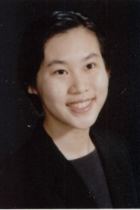
Dr Chih-Hsing HO is Assistant Professor/Assistant Research Fellow at Academia Sinica, Taiwan. Her research focuses on the nexus of law and medicine in general, with particular attention to the governance of genomics and newly emerging biotechnologies, such as big data and biobanks. She is currently a Co-Principal Investigator for a health cloud project in Taiwan, and is responsible for designing an adequate regulatory framework for the secondary use of personal data and health-related data linkage. She holds a Ph.D. in law from the London School of Economics (LSE) where she was an Olive Stone Scholar. She obtained her first law degree from Taiwan, and later received her LLM from Columbia Law School and a JSM from Stanford University. Before moving back to Taipei in 2014, she had been working at the Centre for Medical Ethics and Law (CMEL) at the University of Hong Kong.

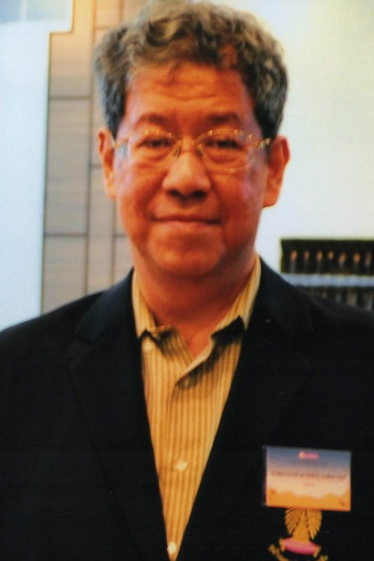
Professor Soraj HONGLADAROM is Professor of Philosophy and Director of the Center for Ethics of Science and Technology at Chulalongkorn University in Bangkok, Thailand. He has published books and articles on such diverse issues as bioethics, computer ethics, and the roles that science and technology play in the culture of developing countries. His concern is mainly on how science and technology can be integrated into the life-world of the people in the so-called Third World countries, and what kind of ethical considerations can be obtained from such relation. A large part of this question concerns how information technology is integrated in the lifeworld of the Thai people, and especially how such integration is expressed in the use of information technology in education. He has organized the second and third Asia-Pacific Computing and Philosophy conferences at Chulalongkorn University in 2005 and 2007. His works have appeared in The Information Society, AI & Society, Philosophy in the Contemporary World, and Social Epistemology, among others.

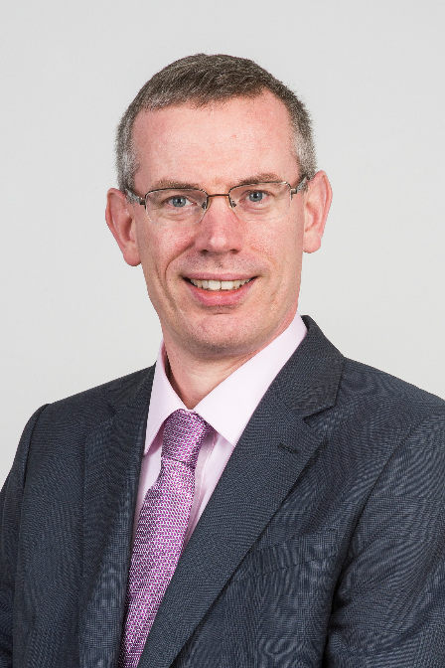
Professor Nick HOPKINS is Law Commissioner for Property, Family and Trusts Law. Prior to appointment in October 2015, Nick had been an academic for over 20 years, holding posts in Durham University, the University of Southampton and the University of Reading, where he has a Chair in Law and was Deputy Head of the Law School. Nick’s academic research included a long standing interest in family property and the family home. Nick has published widely in leading legal journals including the Law Quarterly Review, Modern Law Review and Legal Studies and has spoken extensively at international conferences.

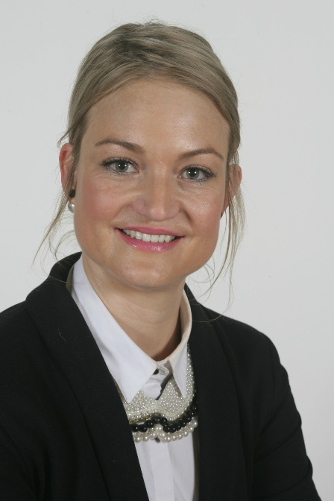
Dr Debbie HORSTEN is a senior lecturer at the Faculty of Law at Stellenbosch University (South Africa). She lectures the first-year module "Law of Persons and the Family" and the fourth-year elective module "Advanced Family Law. Her area of research interest includes a range of topics in the field of child and family law which she approaches from a constitutional perspective.

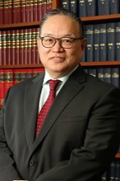
Mr Terry KAAN is Associate Professor of Law, The University of Hong Kong; Co-Director, Centre for Medical Ethics and Law
Terry Kaan’s research interests span from tort law to medical ethics and law. He has published articles and book chapters with regard to the issues of traditional, contemporary and alternative medicine, and genetic privacy. His current research is on how genetic testing impacts doctor-patient relationship.

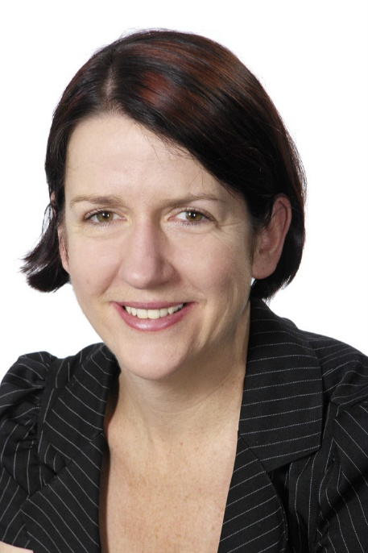
Professor Mary KEYES is Professor and Deputy Head of School for Research at Griffith Law School. She researches principally in private international law, particularly in jurisdiction and international family law. She is co-author of Private International Law in Australia (3rd ed, 2015, with Reid Mortensen and Richard Garnett). She is currently working on a book on party autonomy in private international law, comparing the treatment of agreements in international family law with their treatment in international commercial disputes. Professor Keyes will give a special course at the Hague Academy of International Law in 2020.

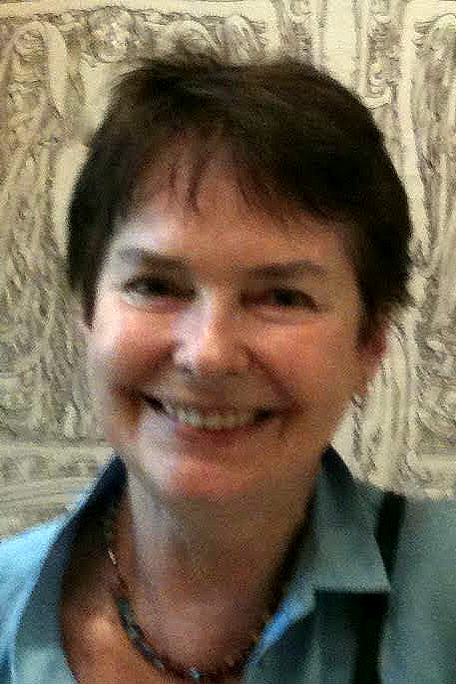
Professor Olga KHAZOVA works at the Institute of State & Law within Russian Academy of Sciences (Moscow). She holds Ph.D. from the same Institute and LL.M. from Cornell University Law School (USA). The main field of her expertise is connected with comparative family law and child law. Apart from teaching, Olga serves as a consultant on family law matters, children’s rights, and human reproduction issues for governmental bodies, courts and law firms. She participated in drafting of the Russian Family Code 1995, and for many years she had been a member of the Expert Group at the Russian Parliament Committee on women, family, and youth matters. She was a member of the Group of Specialists on Child-Friendly Justice, Council of Europe (2009-2010). In 2011-2013, Olga was a key senior expert in the EU project on the Application of the Hague Conventions on Protection of Children in Russia. She is currently a member of the HCCH Expert Group on Parentage/Surrogacy Project. Olga is the author of Marriage and Divorce in Western Family Law and The Art of Legal Writing, as well as of numerous scholarly articles on family law matters published in Russia and abroad. Olga was a British Academy Visiting scholar and was awarded a Fulbright Program scholarship (USA). She taught the courses on Introduction to Russian Law and Child’s Rights in the International Context at the Juridical faculty of Vienna University (2008, 2012 and 2015). She is a regular speaker at international conferences, symposia, and workshops. She is a Vice-President of the International Society of Family Law. Olga is a member of the UN Committee on the Rights of the Child, and in June 2016 she was re-elected to the Committee for the next term.

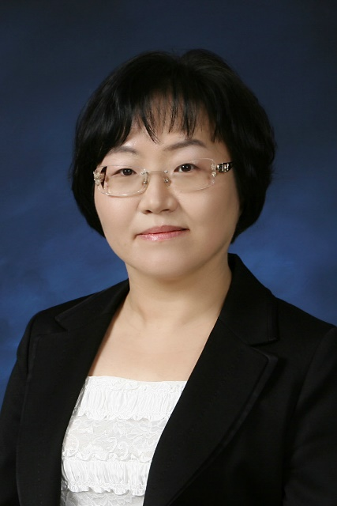
Professor KIM Ock-Joo is a graduate from Seoul National University College of Medicine, trained in biomedical ethics and medical history at University of Minnesota, Harvard University and Western IRB. Since 2002 she has worked in research governance systems including establishment of the KAIRB (Korean Association of IRBs). After the Hwang Scandal, she collaborated with various governmental agencies and academia to rebuild research ethics systems and promote research ethics education in Korea. As an expert in biomedical research ethics, she was involved in the total revision of the Bioethics and Safety Act and the operation of the National Bioethics Policy Institute. She is currently director of the Center for Human Research Protection at the Seoul National University Hospital and a member of IRBs in university and hospitals. She serves as a member of various government committees in bioethics including Central Advisory Committee of Korean Ministry of Food and Drug Administration, and Expert Committee under National Bioethics Review Boards. As a member of the Board of Trustees of the Korean Bioethics Association and the Korean Society for Medical Ethics, she played major roles in publishing biomedical ethics textbooks in Korea, including Clinical Ethics (2014) and Medical Ethics (2015). Her main research areas are clinical ethics, research ethics, and public health ethics and she has published many articles including recently “Ethical considerations of MERS-CoV outbreaks in Korea.”

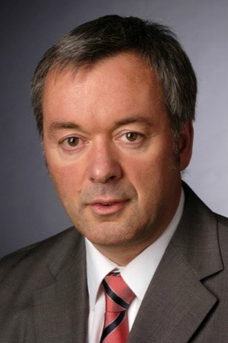
Dr Frank KLINKHAMMER was born in 1961 in Euskirchen, Germany. He studied law at Bonn University and qualified for the German bar in 1990. He then obtained a PhD in law from the University of Bonn. In 1990 he was appointed as judge, and from 1999 to 2008 sat at the Higher Regional Court in Düsseldorf. In 2008 he was appointed as judge at the German Federal Court of Justice (Bundesgerichtshof) in Karlsruhe. As a member of the 12th civil chamber (XII. Zivilsenat) he is mainly concerned with Family Law. Frank also is lecturer at the University of Marburg and one of the editors of the leading German family law journal, FamRZ (Journal of family law) and ZfPW (Academic Private Law Journal). He has published extensively in the area of private law and particularly in family law.
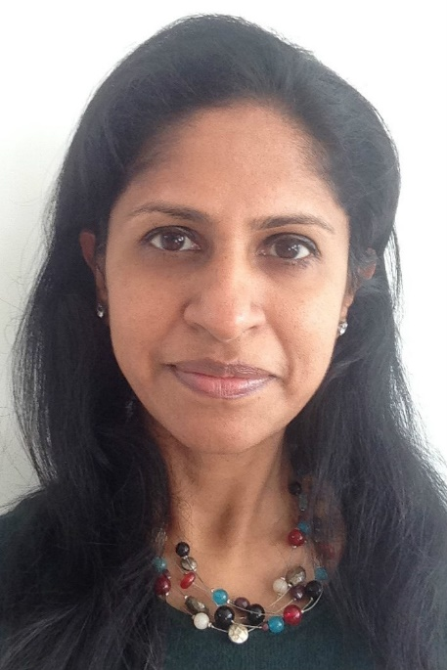
Dr Prahba KOTISWARAN is Reader in Law & Social Justice at King's College London; she previously taught at the School of Oriental and African Studies, London. She received her undergraduate law degree in India from the National Law School of India University, Bangalore and an LLM and SJD from Harvard Law School. Dr Kotiswaran’s main areas of research include criminal law, transnational criminal law, sociology of law, postcolonial theory and feminist legal theory. Her 2011 book Dangerous Sex, Invisible Labor: Sex Work and the Law in India (Princeton) won the 2012 SLSA-Hart Prize for Early Career Academics. Dr Kotiswaran has also edited an anthology on Sex Work (for a Series on Issues in Contemporary Indian Feminism) and special issues of the Journal of Law and Society and the Northern Ireland Legal Quarterly on an economic sociology of law (with Diamond Ashiagbor and Amanda Perry-Kessaris). She is currently engaged in a collaborative project with Janet Halley, Rachel Rebouché and Hila Shamir which critically assesses feminist successes in several arenas of domestic and international law reform. Books resulting from this work include Governance Feminism: An Introduction and a co-edited volume Governance Feminism: A Handbook (forthcoming from the University of Minnesota Press). Her edited volume on Revisiting the Law and Governance of Trafficking, Forced Labor and Modern Slavery is forthcoming from Cambridge University Press.

Dr Kotiswaran is Senior Editor for Oxford Handbooks in Law Online, and on the Editorial Boards of the Canadian Journal of Law and Society and the Jindal Global Law Review, and is a Founding and Contributing Editor of an Open Democracy Blog Beyond Slavery and Trafficking. Dr Kotiswaran’s work has received support from the Arts and Humanities Research Council; the Institute for Global Law and Policy, Harvard Law School; the Hauser Institute for Civil Society, John F. Kennedy School, Harvard; the Journal of Law and Society; the King’s Policy Institute and the Leverhulme Trust.

Her recent publications include:
- Kotiswaran, Prabha and Palmer, Nicola (2015). Rethinking the ‘International Law of Crime’: Provocations from Transnational Legal Studies, Transnational Legal Theory 6(1): 55-88
- Kotiswaran, Prabha (2014). Beyond Sexual Humanitarianism: A Post-Colonial Approach to Anti-Trafficking Law, University of California Irvine Law Review 4 (1): 353-406.
- Kotiswaran, Prabha (2013) "‘Do Feminists Need an Economic Sociology of Law?’" Towards an Economic Sociology of Law, Special issue of Journal of Law and Society, edited by Diamond Ashiagbor, Prabha Kotiswaran and Amanda Perry-Kessaris, (40(1) 115-136.

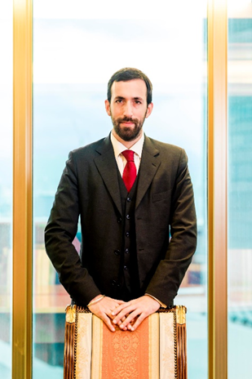
Mr Azan MARWAH is a Hong Kong based barrister and former Judicial Assistant to the Hong Kong Court of Final Appeal. His practice includes family and child law; employment, labour & discrimination law; human rights and public law. He is also a trained and experienced mediator, having previously acted as a court mediator in civil harassment, landlord and tenant, and commercial contracts disputes.
Azan regularly conducts CPD seminars and lectures on family and child law issues and for over 8 years has served as a legal advisor to children’s charities in Hong Kong, including Mother's Choice and PathFinders.
Azan is a contributing editor and author of a number of leading texts including Hong Kong Family Court Practice (2ed) (the 'Red Book'). His other publications include:
- Family Law Practice and Procedure in Hong Kong (2ed) (2015), co-author
- Hong Kong Civil Procedure (White Book) (2015), editor of Order 89 ‘Proceedings between Husband and Wife’ and Order 90 'Proceedings Concerning Minors'
- Atkin's Court Forms Hong Kong (Family volume) (2015) (editor)
- Archbold Hong Kong (2016), editor, Chapter 47 'Companies'
- “Personal Data Privacy in the Digital Age”, Hong Kong Law Journal Vol. 43, Part 3 of 2013, co-author with Bharwaney J)
- Hong Kong Chitty on Contracts (4ed), Chapter 7 ‘Conflict of Laws’

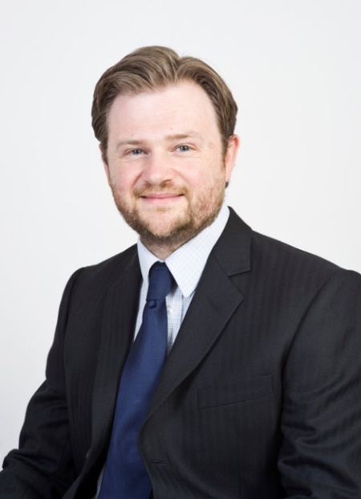
Mr Jolley MATTHEW is team manager of the Property, Family and Trust Law team at the Law Commission for England and Wales. Matthew studied at Oxford University before training and practising at London City law firm Linklaters where he specialised in domestic and international trust law. He joined the Law Commission in 2003, managing the teams running a range of property, family and trust law reform projects alongside the lead Commissioner for those areas. In the family sphere Matthew has worked on the Law Commission’s reform projects on cohabitation; intestacy and family provision; matrimonial property, needs and agreements; the enforcement of family financial orders; weddings; and wills.

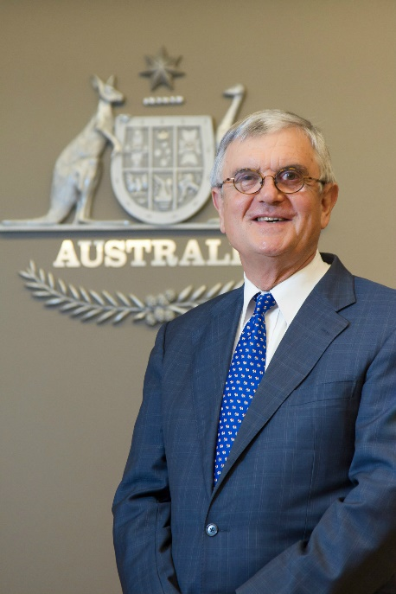
His Honour Chief Judge John PASCOE AC CVO is the Chief Judge of the Federal Circuit Court of Australia, a position he has held since July 2004. The Federal Circuit Court of Australia is a federal trial Court of broad and diverse jurisdiction across all areas of Federal law including Family, Migration, Human Rights, Bankruptcy, Copyright, Industrial, and Admiralty law.

His Honour has been a partner in the legal firm, Stephen Jacques & Stephen and a Managing Direction in the national law firm, Phillips Fox (known now as DLA Piper). He has been Chairman of a number of listed companies and statutory authorities in Australia. His Honour was Deputy Chancellor and a member of the Council of the University of New South Wales and was Deputy Chair of the Institute of Early Childhood Foundation.
He is an Honorary advisor to the Duke of Edinburgh’s Award International Association (Asia Pacific) and is currently serving as a Patron of the LAWASIA Family Law and Family Rights Section. He is also a member of Board of Trustees and the Advisory Board for the Cambodian Children’s Fund Australia. His Honour is the Australian representative to the Hague Conference on Private International Law Experts’ Group on Parentage and Surrogacy.
His Honour was appointed a Member in the General Division of the Order of Australia in 1994, an Officer in the General Division of the Order of Australia in 2002, and was awarded a Centenary Medal in 2003. He was appointed a Commander of the Royal Victorian Order in January 2010, and appointed a Companion of the Order of Australia in 2016, Australia’s highest honour.
His Honour has a particular interest in the elimination of human trafficking in all forms particularly, the trafficking of newly born children.

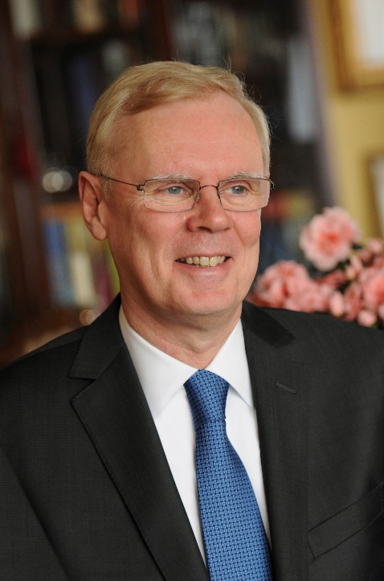
Professor Walter PINTENS is Emeritus Professor, University of Leuven (Belgium). Honorary Professor at Saarland University (Germany). Doctor honoris causa of the University of Regensburg (Germany). Titular member of the International Academy of Comparative Law (Paris). Member of the Scientific Advisory Board of the Max Planck Institute for Comparative and International Private Law (Hamburg)

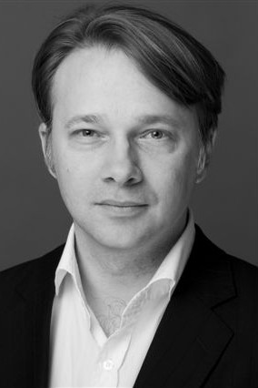
Prof Jens M. SCHERPE is a Senior University Lecturer in Law at the University of Cambridge, Director of The Cambridge Family Law Centre (http://www.family.law.cam.ac.uk), Fellow fo Gonville and Caius College, Cambridge, and Cheng Yu Tung Visiting Professor in Law, University of Hong Kong. He also is an Honorary Fellow of St. John's College/Hong Kong and an Academic Door Tenant at Queen Elizabeth Building, London. Before coming to Cambridge, he was a Senior Research Fellow at the Max Planck Institute for Comparative and International Private Law in Hamburg/Germany. He specialises in comparative law and particularly comparative family law. Jens has held visiting positions in many institutions, including the University of Sydney, the University of Auckland, Queen Mary University of London, the University of Vienna and the Catholic University of Leuven. He has acted as consultant in many cases in England, Germany, Hong Kong and Belgium, including Radmacher v Granatino [2009] EWCA Civ 649, Z v Z (No 2) [2011] EWHC 2878 (Fam) and SA v SPH [2011] HKCFI 1649 (HCMC 1/2011) and CACV 99/2012.
His publications include major comparative studies on cohabitants, same-sex relationships, and, more recently, on the ‘The legal status of transgender and transsexual persons’ (Intersentia Publishing, 2015) and ‘Marital agreements and private autonomy in comparative perspective’ (Hart Publishing, 2012. In 2016 he edited a four volume book set on European Family Law, including a monograph on ‘The Present and Future of European Family Law' (all Edward Elgar Publishing 2016. His comparative Studies on ‘The Future of Registered Partnerships’ (together with Andrew Hayward) and “The Legal Status of Intersex Persons” (together with Anatol Dutta and Tobias Helms) will be published in 2017 (by Intersentia Publishing). Jens' full list of publications can be found at http://www.law.cam.ac.uk/people/academic/jm-scherpe/1231.

Professor Rhona SCHUZ is Professor of Law and Co-Director of the Center for the Rights of the Child and the Family at the Sha'arei Mishpat Law School Israel and Adjunct Professor of Law at the Faculty of Law, Bar Ilan University. Before moving to Israel, she was a lecturer in law at the London School of Economics. She has an MA in law and an LLM from the University of Cambridge and a PhD from the University of London. Rhona has written extensively in the areas of child law and private international law, with particular emphasis on children's rights, international child abduction and surrogacy in Israel. In addition to numerous articles, she has published two books, A Modern Approach to the Incidental Question in the Conflict of Laws (Nijhoff, 1997) and The Hague Child Abduction Convention: A Critical Analysis (Hart, 2013).

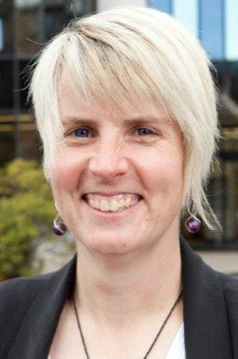
Dr Debra WILSON is a Senior Lecturer in Law at the University of Canterbury in New Zealand. Specialising in Medical Law, she has a strong interest in both the regulation of assisted reproductive technologies and issues in relation to the ability of a parent/guardian to consent to medical treatment for a child. She has written and presented widely in relation to assisted reproduction, and is the author of two chapters in a leading NZ text on Child Law in this area. A current Erskine Fellow at Cambridge and Rutherford Visiting Scholar at Trinity College, Debra has previously been a Fulbright Visiting Scholar at Georgetown University and an Erskine Visiting Fellow at Oxford. She is currently the Primary Investigator on a three year externally funded (NZ Law Foundation) project entitled “Te Kohuki Ture Kopu Whangai: Rethinking Surrogacy Laws”.

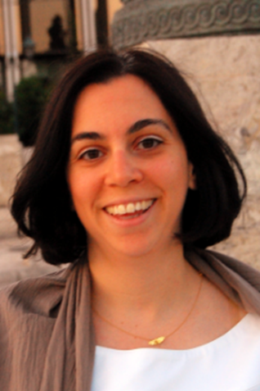
Dr Eleni ZERVOGIANNI was born in Athens (Greece) in 1978. In 2000 she graduated from the Law School of the University of Athens and in 2001 she obtained the "European Master in Law and Economics" from the Law Faculty of the University of Hamburg. In 2006 she received her Ph.D. degree with honours from the Law School of the University of Athens. During her doctoral and post doctoral studies she was awarded scholarships from various institutions (such as the Hellenic State Scholarships Foundation, the ‘Alexander S. Onassis Public Benefit Foundation’, the Max-Planck-Institute for Foreign and Private International Law in Hamburg and the Swiss Institute of Comparative Law in Lausanne), while she was also granted a ‘Marie Curie Fellowship’.
Eleni Zervogianni is since November 2015 Assistant Professor of Civil Law at the Law Faculty of Aristotle University of Thessaloniki, where she had previously served as a Lecturer (since February 2011). She has taught numerous courses in Greek, both at an undergraduate and a postgraduate level, covering the whole field of Civil Law. She has also offered courses in English on ‘European Contract Law’, ‘Introduction to Greek Civil Law’ and ‘Introduction to Comparative Law’. Her research focuses mainly on the Law of Obligations as well as on Family and Succession law, both from a national and comparative law perspective. She is the author of two books and more than 50 articles and contributions to collective works. She is also co-editor, together with Ass. Prof. Marta Infantino (University of Trieste) of the Common Core Project on ‘Causation in European Tort Law’. She has participated in many conferences in Greece and abroad.
She is member of the Athens Bar Association, Associate at the Hellenic Institute of International and Foreign Law (without pay), Scientific Associate of the Greek law journal “Efarmoges Astikou Dikaiou” and member of the editing board of the Canadian journal “Review of European Studies”. She has served as referee for various scientific journals and she is a member of many scientific associations.

Directions & Contact Information

By MTR (recommended, see below for marked station exits):
- HKU Station Exit A1.
By taxi via East Gate or via Pokfulam Road and then by foot
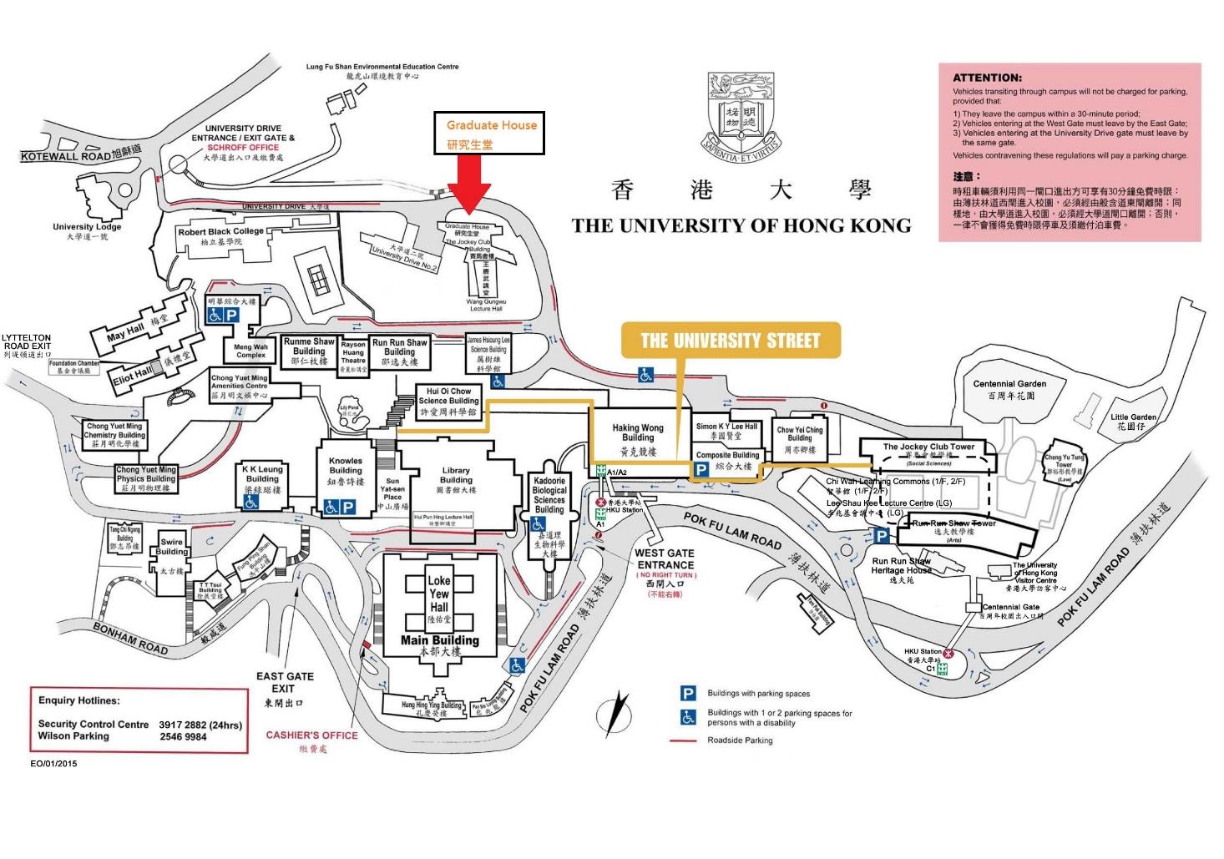
Contact LML | Contact CMEL
Centre for Law, Medicine and Life Sciences  University of Cambridge  lml@law.cam.ac.uk  http://www.lml.law.cam.ac.uk | Centre for Medical Ethics and Law  The University of Hong Kong  cmel@hku.hk  www.cmel.hku.hk

